## User Guide

On this section the author will explain step by step how to use the application in question and what the error messages means. the picture below shows the flow of the application.

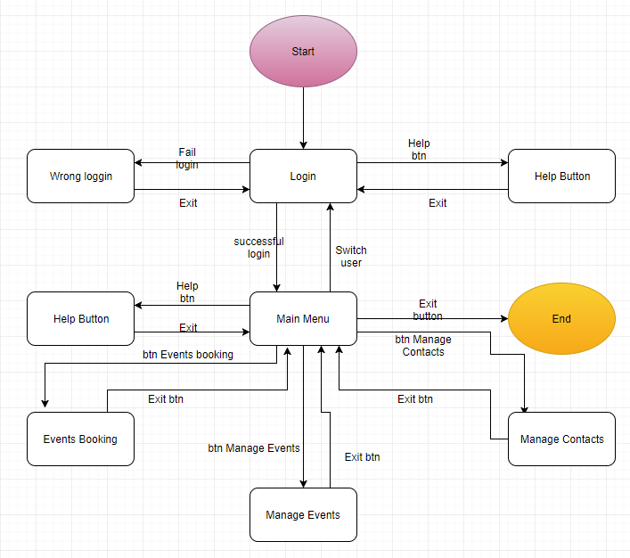

### Login

After starting the application, you get placed in the login window, there you have 2 text boxes and 2 buttons.

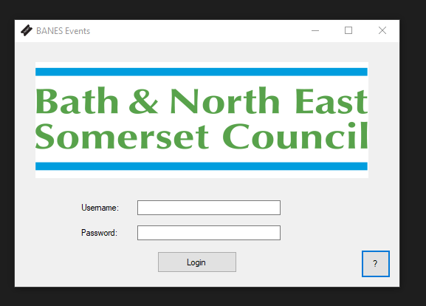

* Text box username: here you type your username
* Text box password: here you type your password
* Button Login: this button you press once you typed in your username and password
* Button ‘?’: is a help button explaining what the login window can do.

It is straight forward here, if you get username or password wrong you get a message box saying that the username or password is incorrect, press ok and try again.

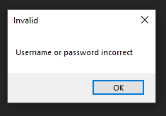

If username and password is correct you get directed straight into the main menu.

### Main Menu

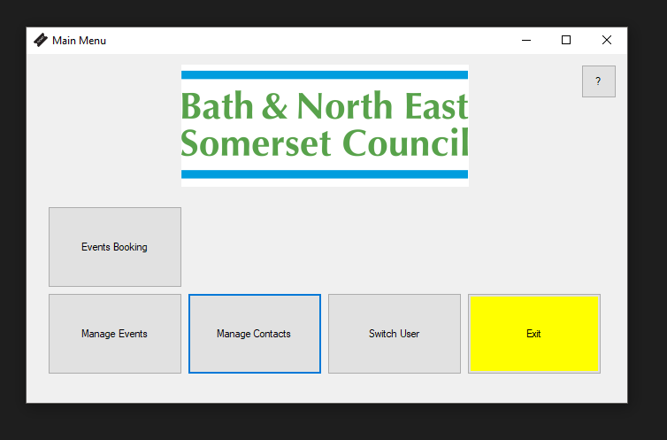

This is the main menu, here is where all the program applications are. You have the following buttons:

* Events bookings: this leads you to the sale of tickets to customers.
* Manage events: this leads you to manage events in the database.
* Manage contacts: lets you add and update the contacts in the database.
* Switch user: allows you to switch user.
* Exit: allows you to quit the application.
* Help button ‘?’: opens a help window explaining the functionality of the main menu page, you can close it by pressing ‘X’ on the top righthand corner.

### Events Booking

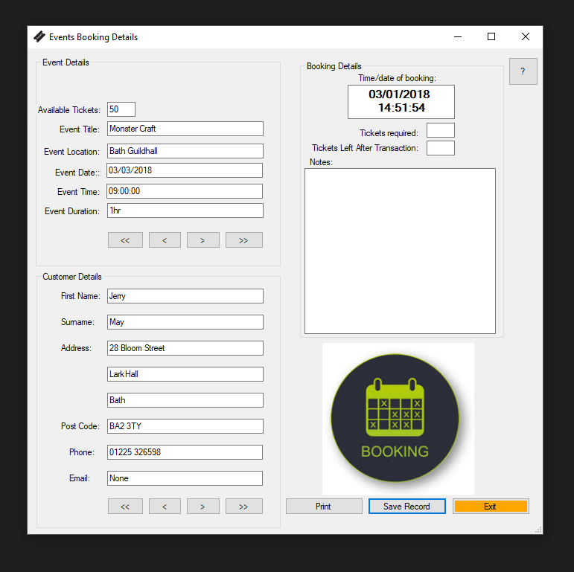

In this part of the application you have 4 sections:

* Event details: it holds 6 information boxes and 4 navigation buttons.
* Customer Details: it holds 8 information boxes and 4 navigation buttons.
* Booking Details: it holds 4 information boxes, one is the time and date which is set automatically, tickets required which asks input from the user and the tickets left is updated by the application according to the total amount of available tickets and the tickets required and notes section where you can add any information to that transaction
* The form buttons: includes print, save record, exit and the help button ‘?’, the print button prints a copy of the form with all the information that is currently on the window.

Once you have found the correct event details and the correct customer details, you must input the required amount of tickets needed for this transaction and a notes section for any information that might be needed to add to that transaction. You can then press the print button if needed it is not a requirement to print. You can then save the record (transaction), this will update the database with the available tickets and sold tickets and save the information of this transaction to a text file in the root of the application for audit purposes, the application if successful will close taking the user back to the main menu form, if not then he will have an error message, informing that the user needs to adjust the number of tickets required.

### Manage Events

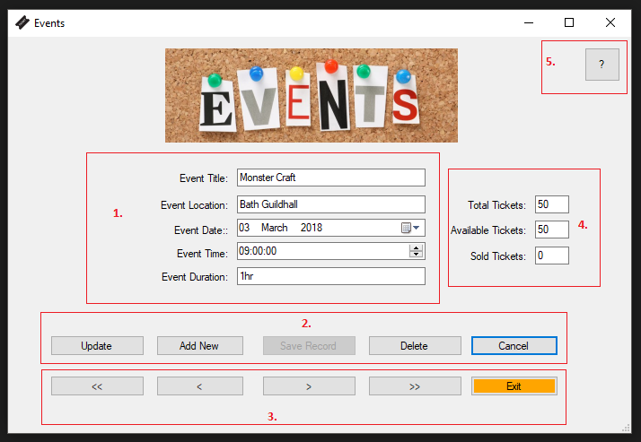

In this form you have 5 sections that the user needs to know and can interact with.

Section 1, has all the events information, title, location, date/time etc. you can see that the date and time information boxes are different then the others, that is because they are date and time picker boxes, which makes life easier for the user, all that the user needs to do is click on the box and pick the time and date that he wants.

Section 2, this section holds 5 buttons:

* Update, this allows the user to update the above information of an existing event.
* Add new, this allows the user to add a new record, what happens here is that once this button has been pressed it will activate the save record button, it will clear all the information in section 1, it will enable the save record which was disabled before, will disable all the navigation records and will disable 3 other buttons update, add new and delete (u can see that on the picture below).

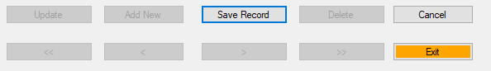

Section 3, has all the navigation records that control the information in section 1 and the exit button.

Section 4, holds the information of all the tickets of that event.

Section 5, is the help button explaining the user what the current form does.

### Manage Contacts

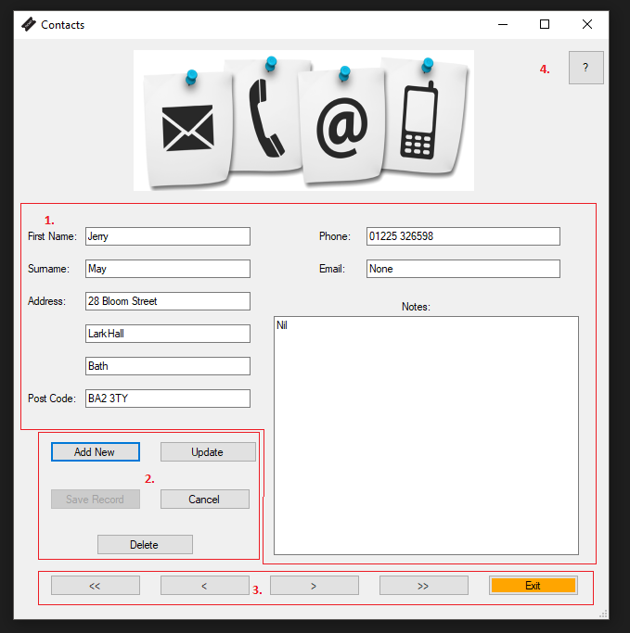

In this form you have 4 sections. Here you can add/update your list of contacts.

Section 1, holds all the information of the contacts.

Section 2, holds all the buttons that will update/change the information in the database. Add new, this allows the user to add a new record, what happens here is that once this button has been pressed it will activate the save record button, it will clear all the information in section 1, it will enable the save record which was disabled before, will disable all the navigation records and will disable 3 other buttons update, add new and delete (u can see that on the picture below).

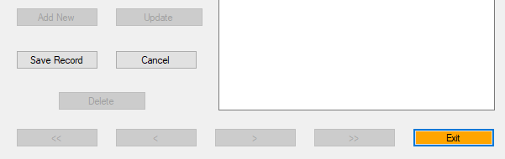

Section 3, has all the navigation records that control the information in section 1 and the exit button.

Section 4, is the help button explaining the user what the current form does.